**DAILY ONLINE ACTIVITIES SUMMARY**

|  |  |  |  |  |  |  |
| --- | --- | --- | --- | --- | --- | --- |
| **Date:** | **06/06/2020** | | | **Name:** | **JASLINE SHARON TAURO** | |
| **Sem & Sec** | **4th sem, A Section** | | | **USN:** | **4AL18CS029** | |
| **Online Test Summary** | | | | | | |
| **Subject** | | **DATA COMMUNICATION** | | | | |
| **Max. Marks** | | **30** | | **Score** | **30** | |
| **Certification Course Summary** | | | | | | |
| **Course** | **Trailhead Basics** | | | | | |
| **Certificate Provider** | | | **SALES FORCE** | **Duration:** | | **3 HRS** |
| **Coding Challenges** | | | | | | |
| **Problem Statement:**   1. Write a Java Program to find the second-highest number in an array. 2. Write a program in C to rotate an array by N positions. 3. Write a java program given an array A of size N containing 0s, 1s, and 2s; you need to sort the array in ascending order. | | | | | | |
| **Status: DONE** | | | | | | |
| **Uploaded the report in GitHub** | | | | **YES** | | |
| **If yes Repository name** | | | | [**https://github.com/jaslinesharontauro/C_Prgms**](https://github.com/jaslinesharontauro/C_Prgms)  <https://github.com/jaslinesharontauro/JAVA_Prgms> | | |
| **Uploaded the report in slack** | | | | **YES** | | |

**Online Test Details: (Attach the snapshot and briefly write the report for the same)**

**Certification Course Details: (Attach the snapshot and briefly write the report for the same)**

**Coding Challenges Details: (Attach the snapshot and briefly write the report for the same)**

**1.ONLINE TEST DETAILS:**

**Today we had assessment in the subject DATA COMMUNICATION. It was based on fifth module of this subject. There were total 30 number of questions of ONE mark each, out of which I scored 30.**

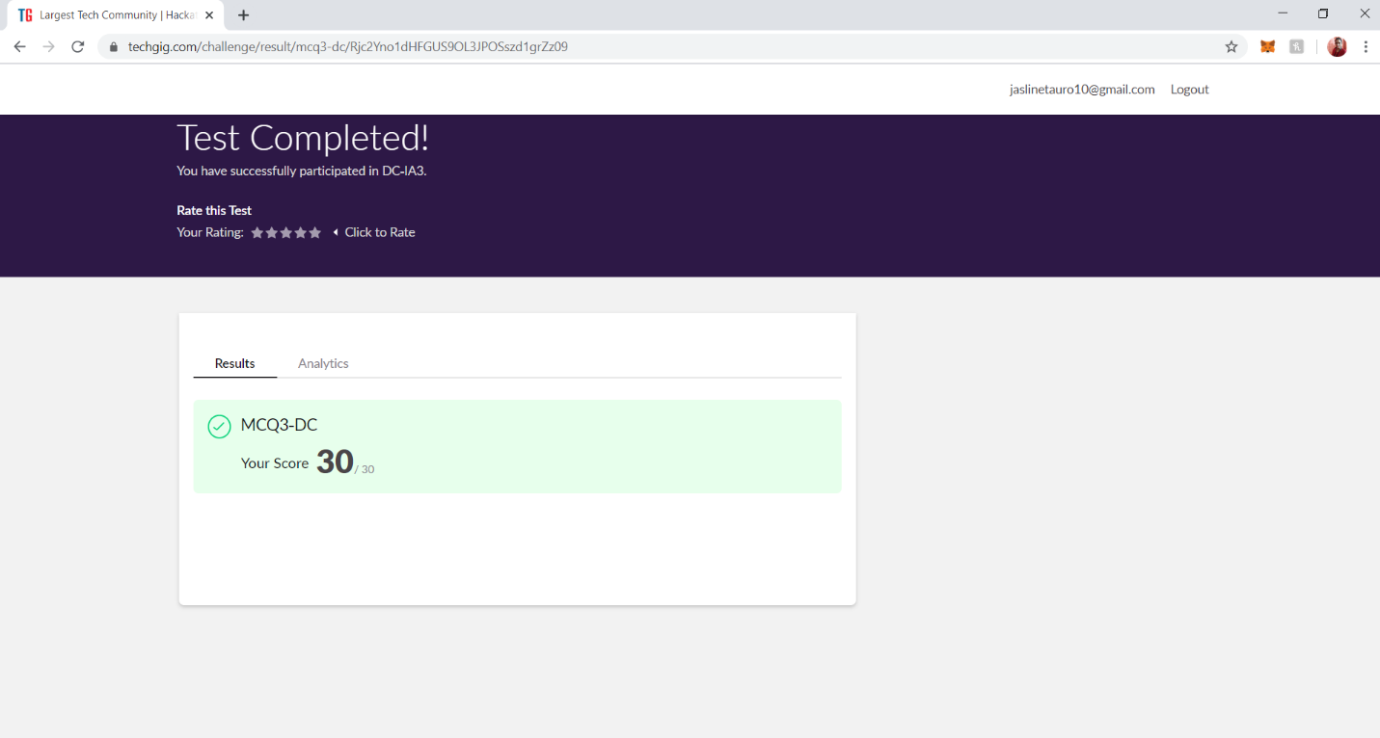

**2.CERTIFICATION COURSE DETAILS**

I have done certification course on the 8th module of TRAILHEAD BASICS by SALES FORCE. Today I learnt about next chapter of the module FORMULAS AND VALIDATIONS. In which I learnt “Introduction to Roll-up summary fields” and about “Master-Detail Relationship”.

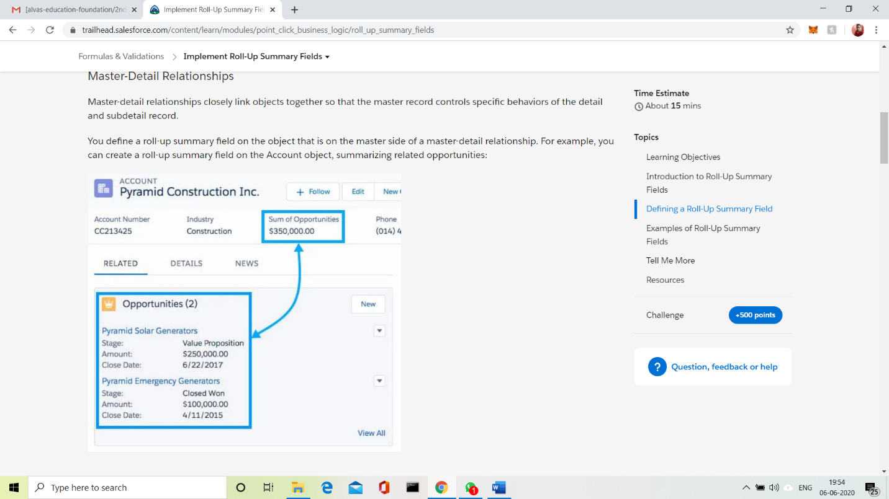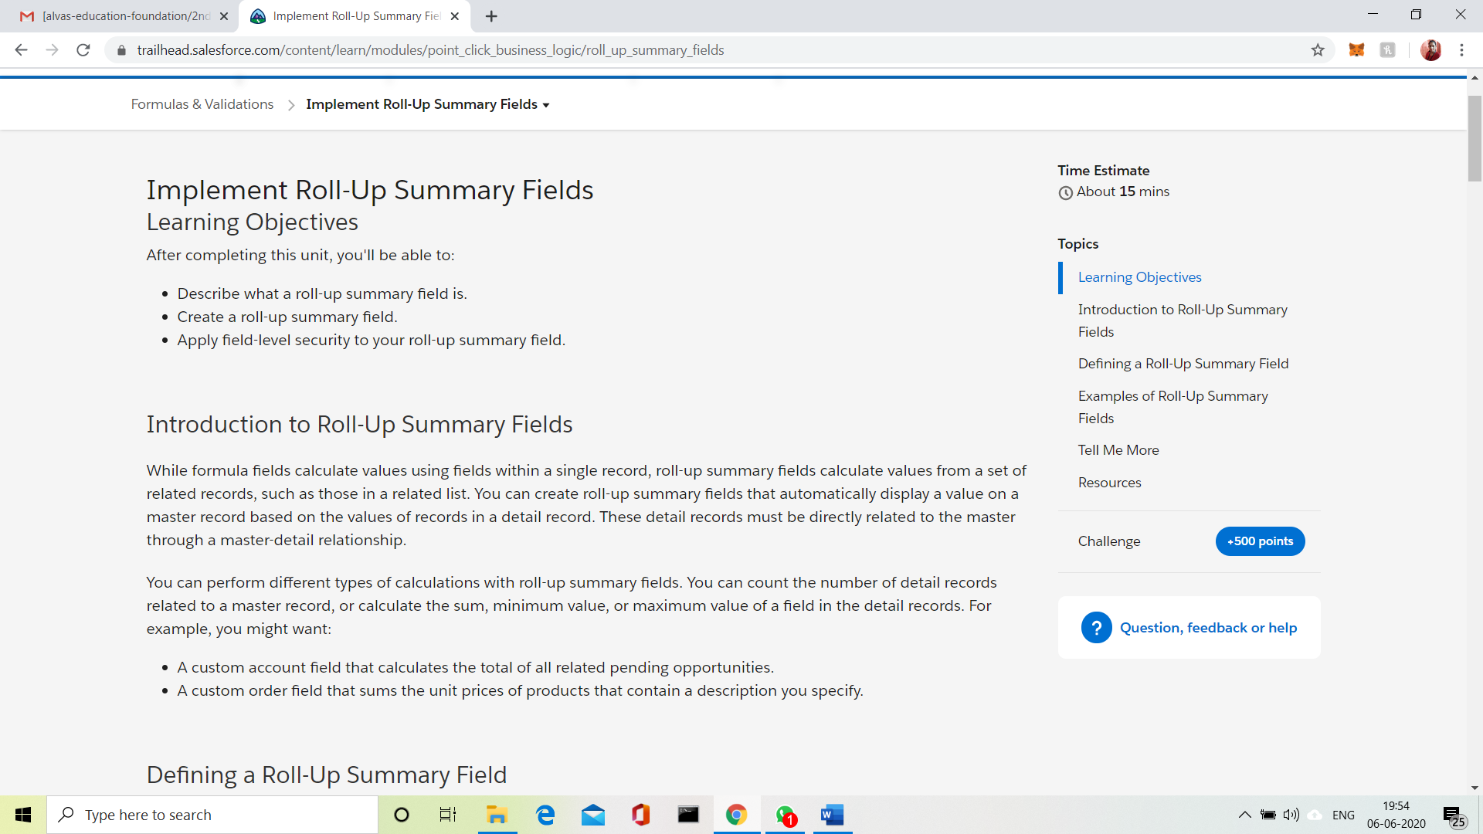

**3.CODING CHALLENGES DETAILS:**

**Problem Statement 1:**

Write a Java Program to find the second-highest number in an array.

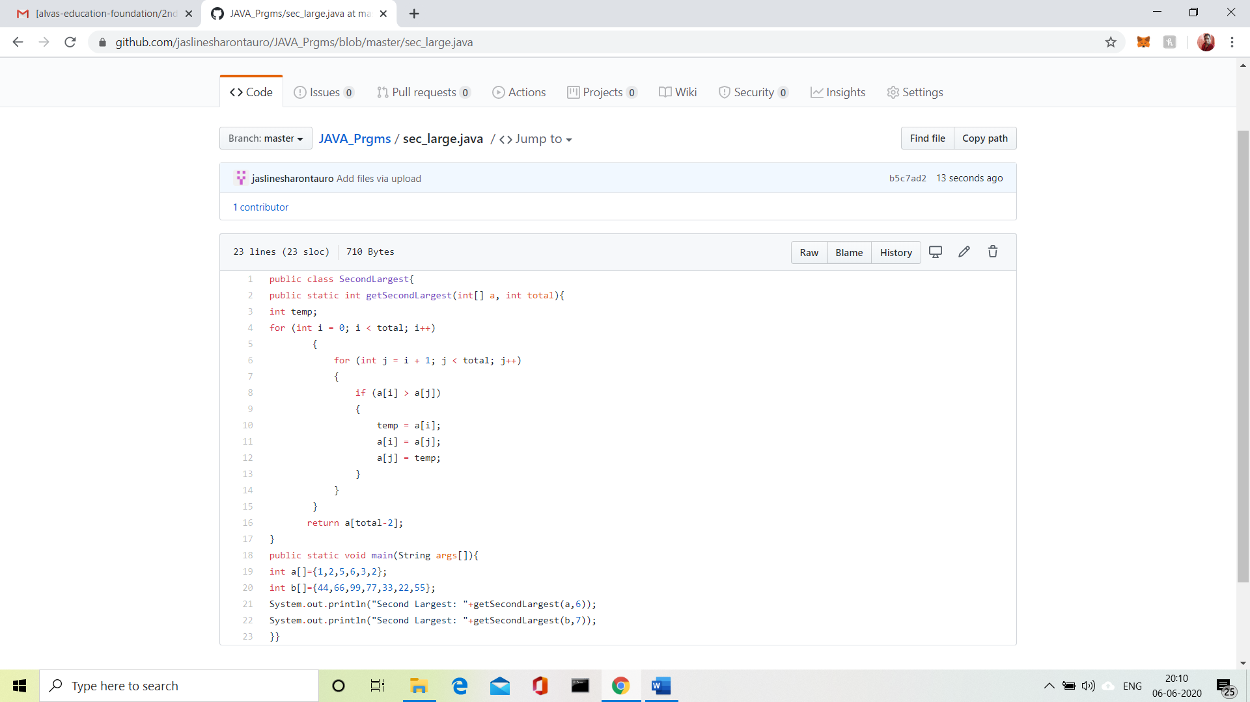

Problem Statement 2:

Write a program in C to rotate an array by N positions.

**Expected Output :**  
**The given array is :** 0 3 6 9 12 14 18 20 22 25 27  
Enter the Position N from where you want to rotate: 4  
From 4th position the values of the array are : 12 14 18 20 22 25 27  
Before 4th position the values of the array are : 0 3 6 9  
After rotating from 4th position the array is:  
12 14 18 20 22 25 27 0 3 6 9

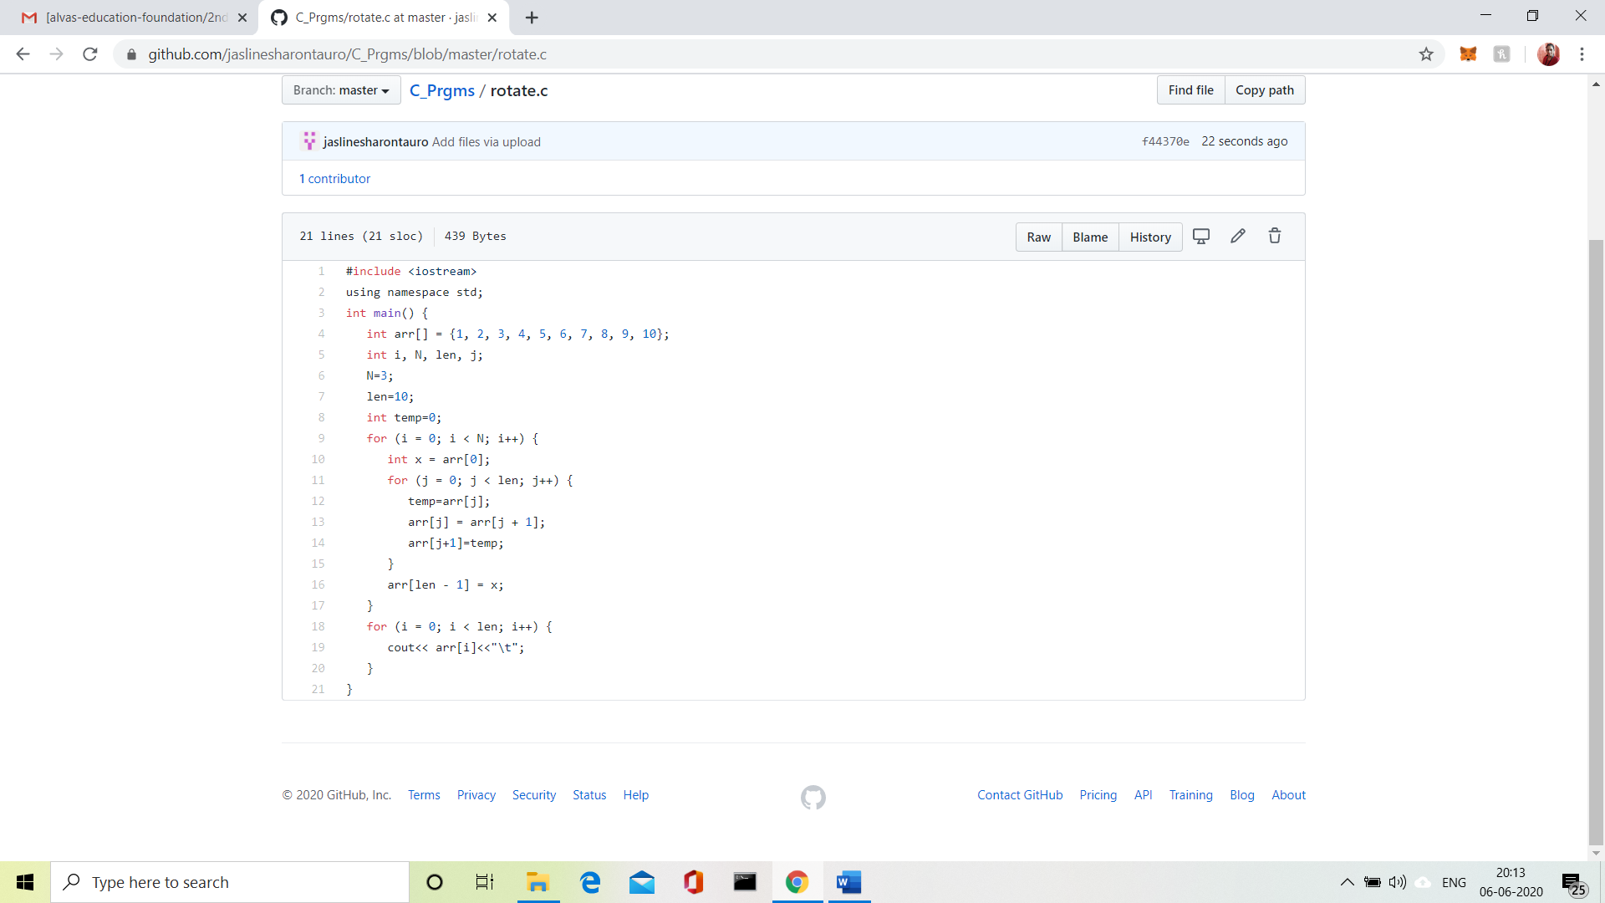

**Problem Statement 3:**

Given an array A of size N containing 0s, 1s, and 2s; you need to sort the array in ascending order.

Input:  
The first line contains an integer 'T' denoting the total number of test cases. Then T testcases follow. Each testcases contains two lines of input. The first line denotes the size of the array N. The second lines constrains the elements of the array A separated by spaces.

Output:  
For each testcase, print the sorted array.

Constraints:  
1 <= T <= 500  
1 <= N <= 106  
0 <= Ai <= 2

Example:  
Input:  
2  
5  
0 2 1 2 0  
3  
0 1 0

Output:  
0 0 1 2 2  
0 0 1

